**Cryptography and Network Security**

**B.Tech. (CSE) – I [ 2022-23 ]**

**Assignment No - 2**

# **Implement Cryptanalysis**

**Aim**: Implement Cryptanalysis in cpp

**Theory**: In this we will perform decryption technique on given cipher code .Check each string after each iteration for plain text.

IMG_256

(Decryption Phase with shift n)

Text : ABCDEFGHIJKLMNOPQRSTUVWXYZ

Shift: 23

Cipher: XYZABCDEFGHIJKLMNOPQRSTUVW

**Code**:

#include <iostream>

using namespace std;

int main()

{

    cout<<"Cryptanalysis Brute force attack: ";

    string cipher;

    cout << "Enter cipher text: ";

    cin >> cipher;

    string temps;

    for (int key = 0; key < 26; key++)

    {

        temps = cipher;

        int temp;

        for (int i = 0; i < temps.size(); i++)

        {

            temp = (temps[i] - key - 65) % 26;

            if (temp < 0)

                temp = 26 + temp;

            temps[i] = temp + 97;

        }

        cout << key << " : " << temps << endl;

    }

}

**Output:**

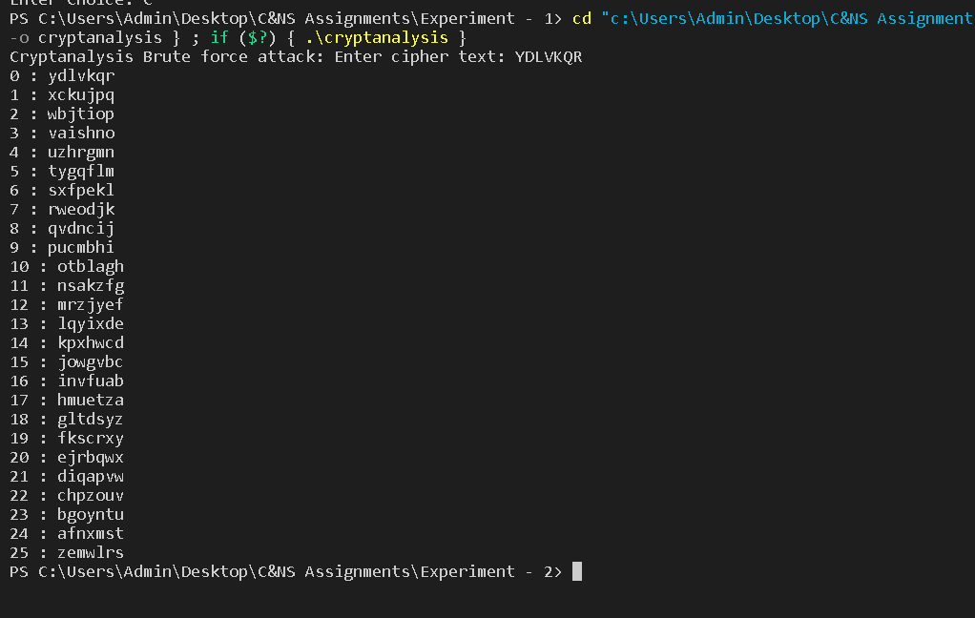

**Conclusion**:

So in this way by performing max 26 iterations we can decode original text.